**UNIT 2. SOCIALIZING**

**Task 1. First look at some of the activities involved in socializing. Match pictures with appropriate activities offered below**: *greeting a visitor, chatting during tea or coffee break, introducing visitors, showing visitors around your office or town, taking a visitor out for lunch or dinner, making small talk at a meeting, networking at a trade fair or a conference.* **Can you add anything?**

|  |  |
| --- | --- |
|  |  |
|  |  |
|  |  |
|  |  |
|  |  |
|  |  |
|  |  |
| **CUSTOMER FOCUS EXTRA** | |
| Good basic socializing skills help build your customer base. From the beginning, your customers will see how you show interest and pay attention. This is an important step in establishing a rapport with your customers. Small talk may seem to deal with unimportant topics, but it is necessary for ‘breaking the ice’ with customers. People can relax and get comfortable with light topics. Be careful with choosing topics for small talks. Depending on your customer’s cultural background, they might find the topics too aggressive or too personal in a business context. | |

**Task 2. Read the text about small talk „ Small Talk: Who, What, Where, When, Why“. Form 10 questions to the given text below.**

**WHO makes small talk?**

People with many different relationships use small talk. The most common type of people to use small talk are those who do not know each other at all. It is also common for people who are only acquaintances, often called a "friend of a friend", to use small talk. Other people who have short casual conversations are office employees who may not be good friends but work in the same department. Customer service representatives, waitresses, hairdressers and receptionists often make small talk with customers.

**WHAT do people make small talk about?**

There are certain "safe" topics that people usually make small talk about. The weather is probably the number one thing that people who do not know each other well discuss. Another topic that is generally safe is current events. Entertainment news, such as a celebrity who is in town, is another good topic. If there is something that you and the other speaker has in common, that may also be acceptable to talk about. For example, people in an office might casually discuss the new paint or furniture. There are also some subjects that are **not** considered acceptable when making small talk. Discussing personal information such as salaries or a recent divorce is not done between people who do not know each other well. Compliments on clothing or hair are acceptable; however, you should never say something (good or bad) about a person's body. Also, it is not safe to discuss religion or politics.

**WHERE do people make small talk?**

People make small talk just about anywhere, but there are certain places where it is very common. Most often, small talk occurs in places where people are waiting for something. For example, you might chat with another person who is waiting for the bus to arrive, or to the person beside you waiting to get on an aeroplane. People also make small talk in a doctor's or dentist's waiting room. At the office, people make small talk in elevators or lunchrooms. Some social events (such as a party) require small talk among guests who do not know each other very well.

**WHEN do people make small talk?**

The most common time for small talk to occur is the first time you see or meet someone. For example, if you see a co-worker in the lounge you might say hello and discuss the sports or weather. However, the next time you see each other you might just smile and say nothing. Do not interrupt two people in order to discuss something unimportant such as the weather. If someone is reading a book or writing a letter it is not appropriate to initiate a conversation either. Another good time to make small talk is during a break in a meeting or presentation when there is nothing important going on.

**WHY do people make small talk?**

There are a few different reasons why people use small talk. The first, and most obvious, is to break an uncomfortable silence. Another reason, however, is simply to fill time. Some people make small talk in order to be polite. You may not feel like chatting with anyone at a party, but it is rude to just sit in a corner by yourself. After someone introduces you to another person, you do not know anything about them, so in order to show a polite interest in getting to know them better, you have to start with some small talk.

**Form 10 questions to a given text you have read above:**

1. ___________________________________________________________________________
2. ___________________________________________________________________________
3. ___________________________________________________________________________
4. ___________________________________________________________________________
5. ___________________________________________________________________________
6. ___________________________________________________________________________
7. ___________________________________________________________________________
8. ___________________________________________________________________________
9. ___________________________________________________________________________
10. ___________________________________________________________________________

**Task 3. Which of the topics you would talk to a) a friend or a colleague; b) an important business partner. Put a tick (√) or a cross (x).**

|  |  |  |
| --- | --- | --- |
| **Topics** | **Friend / Colleague (informal / neutral)** | **Business Partner (formal)** |
| Family |  |  |
| International politics |  |  |
| The salary or wage |  |  |
| Travel |  |  |
| Weather |  |  |
| Food&drink |  |  |
| Religion |  |  |
| Health |  |  |
| Sports |  |  |
| Global warmimg, pollution, environmental protection |  |  |
| Your hobbies |  |  |
| Corruption |  |  |
| Computers and new technology |  |  |

**Task 4. Talking about what you do in your free time (e.g. hobbies, sport) is a popular small-talk topic. Complete the free time activities below by writing in the missing vowels (a, e, i, o, u). Can you add three more activities to each list.**

|  |  |  |
| --- | --- | --- |
| **SPORT** | **RELAXING AT HOME** | **GOING OUT** |
| Sk _ _ ng | L _ st _n_ ng to m _ s _ c | _ _t _ ng out |
| D _ _ ng y _ g _ | R_ _d_ ng | G_ _ ng t_ th _ c _ n _ m_ |
| K _ _ p _ ng f _t | W _ tch _ng T _ l _ v _ s _ _ n | Sh _ pp _ ng |
| Pl _y _ ng f _ _tb _ll | C _ _ k_ ng | G_ _ ng to c _ nc _rt |
|  |  |  |
|  |  |  |
|  |  |  |

**While welcoming visitors from abroad, it would be a good idea to continue your small-talk and inviting him/her somewhere. Read some examples of how to accept and turn down the invitations.**

|  |
| --- |
| **CUSTOMER FOCUS EXTRA** |
| **INVITATIONS**  **Accepting invitations:**  That would be kind / lovely / great. That sounds great.  Thank you, I‘d like that very much. Excellent / good idea. Let‘s do that.  **Turning down invitations:**  It is more difficult to say ‚No‘ to invitations and still be polite  Below are some examples how to turn down the invitation.   |  |  |  |  | | --- | --- | --- | --- | | **1 thank the person** |  | **2 give a reason** | **3 offer an alternative** | | That‘s really kind of you | but | My flight‘s at 5.30p.m. so i should probably stay in town just to make sure i get for check in on time | Perharps we can do it next time I‘m in town | | That‘s very nice of you | But actually | I‘m afraid my boss wants my conference report tomorrow so i need to stay in the hotel and prepare my presentation | But may be we could visit Gallery tomorrow evening? | | I‘d love to (come) | however | I‘m afraid i just do not have time today | How about having dinner sometime next week? | |

**Task 5. Make small role plays inviting your business contact to some offered places below. Keep the tips from a table above accepting or turning down the invitations.**

|  |  |
| --- | --- |
| **Partner A** | **Partner B** |
| You are looking after a visitor to you town/city. You would like to spend as much time with your business contact as possible. Here are some places you could visit with him / her. Make suggestions about what you do.   1. City AquaPark – has a huge swimming pool with various slides and wave machine. 2. Opera Theatre – has a version of Cristmas performance „Nutcracker“ at the moment which is supposed to be very good. The ballet is three hours. 3. Bohemian Cafe – Historic cafe built in 1930. One of the big tourist sights in your city. Specializes in traditional national dishes. 4. Photography Gallery – exposition of the most famous photographers works all over the world – 30 minutes‘ drive from the city. | You are visiting an important contact in another town/city. You would like to spend time with him/her, but you have a loto f things to think about today:   * You have an important presentation to prepare for tomorrow. It will take at least three hours to prepare. * Today is your husband‘s birthday. You have to phone home this evening to wish him a happy birthday. * You hurt your arm playing tennis last week and you still feel the pain.   Your partner will invite you do different things. Respond to his /her invitations. Don‘t forget the things you have to do today. At the same time, remember that this is an important business relationship and that you have to accept at least one invitation! |

**Task 6. Think of 5 interesting places in your town or city. Prepare a short talk providing details about them such as key dates, historical facts, and interesting data. Use the Internet if you need to check your information. Present your information to the rest of the class and give them a ‚virtual‘ tour of your town.**

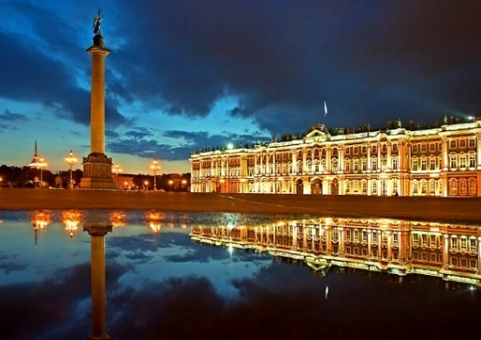

**Task 7. Talking about places you have visited is a common small-talk topic. Choose one line from each column to make a mini-dialogue.**

|  |  |  |
| --- | --- | --- |
| **Person A** | **Person B** | **Person A** |
| 1.So is this the first time in Lithuania? | a.Yes, very much. Especially Christmas Fair. | A.I know. It‘s always a problem, isn‘t it? |
| 2.Have you ever been to Greece? | b.No, this is my first time. What about you? | B. That‘s good. You had some time to relax. |
| 3.Did you enjoy your visit to Berlin? | c. No, it was actually a business trip. But I had one day free. | C. Oh really? Was that for business or pleasure? |
| 4. Have you been here before? | d.We found this wonderful sophisticated hotel in the centre of the town, not far from the Opera house. | D. It‘s my first time here as well. |
| 5. What did you think of Manchester? | e. Actually, I was here once before, in 2012. | E. Sounds great! Do you remember the title? |
| 6.Were you there on holiday? | f. It‘s an amazing city. Pity about traffic jams though! | F. You should. It‘s really a great country full of history and traditions |
| 7. Where did you stay when you were there? | g. No, but I‘d love to go there sometime. | G.I know, it‘s amazing, isn‘t it? |

**Task 8. Work with a partner to practise a small talk conversation with a visitor. Choose one of three given situations and prepare a role play.**

1. You were assigned to pick up a guest flying from Helsinki at the airport. It is 7p.m. now. You need to get a taxi for your guest and then ride with him / her to the hotel. On the ride, you need to have a small talk with your guest.
2. You were assigned to pick up a guest coming from Singapore at the hotel. It is 8p.m. now. You need to bring your guest to the conference where s/he will give a talk. The institution has sent a car with a driver waiting outside the hotel to take both of you to the conference. On the ride, you need to have a small talk with your guest.
3. You were assigned to take your guest to a tour around Vilnius for one day. It is 9a.m. now. You need to find out what s/he would like to see, to do and to eat in Vilnius. On the ride, you need to have a small talk with your guest.

**Task 9. Form Nouns from the given Verbs below, choose any 10 words and create your own sentences:**

|  |  |
| --- | --- |
| **Verb** | **Noun** |
| 1. To discuss |  |
| 1. To arrive |  |
| 1. To require |  |
| 1. To interrupt |  |
| 1. To introduce |  |
| 1. To accept |  |
| 1. To consider |  |

1. __________________________________________________________________________
2. __________________________________________________________________________
3. ___________________________________________________________________________
4. ___________________________________________________________________________
5. ___________________________________________________________________________
6. ___________________________________________________________________________
7. ___________________________________________________________________________
8. ___________________________________________________________________________
9. ___________________________________________________________________________
10. ___________________________________________________________________________

**Task 10. Read an example of a dialogue ‘Welcoming someone at the office ‘ and practise your own version.**

|  |  |
| --- | --- |
| Linda | Good morning, Ms Lee. Do come in. Welcome. It’s nice to see you again. |
| Rahel | Nice to see you too, I’ve been very much looking forward to this visit. |
| Linda | So have we. May I take your coat ? |
| Rahel | Certainly. Here you are. |
| Linda | Please have a seat, and make yourself comfortable. I’ll tell Mr Rockman you are here. Would you like something to drink ? |
| Rahel | Yes, I wouldn’t mind a hot drink. |
| Linda | Of course. We have tea and coffee. What would you prefer ? |
| Rahel | Coffee would be great, thank you. |
| Linda | How would you like your coffee ? |
| Rahel | With milk and one sugar, please. |
| Linda | Here you are. Please help yourself to the cookies. |
| Rahel | They look delicious, thank you. |
| Linda | You’re welcome. did you have any trouble finding the way ? |
| Rahel | No, the directions you sent me were very clear, but it took some time to wait for necessary bus. |
| Linda | Excellent. How’s Mr Svenson? |
| Rahel | He’s very well. He sends his best wishes. |
| Linda | It’s a pity he couldn’t join us today. |
| Rahel | Indeed. He would have really liked to come, but unfortunately he wasn’t able to rearrange his schedule. |
| Linda | Well, I certainly hope he can join us on your next visit. As for today’s schedule, we thought we could have lunch first and then show you around the company. Do you like the idea? |
| Rahel | Yes, it is excellent idea. I’d really like to see your new premises. |
| Linda | Certainly. Well, I think that’s Mr Rockman coming now. |
| Rahel | Splendid. Thank you very much. |

**Task 11. Work with a partner to practise meeting a customer for the first time. Use the flow chat below.**

|  |  |  |
| --- | --- | --- |
| **A.** |  | **B.** |
| Introduce yourself |  |
|  | Respond |
| Offer hospitality. (coat / umbrella / something to drink) |  |
|  | Respond |
| Ask a ‚small talk‘ question |  |
|  | Respond. Ask a follow up question. |
| Respond. Ask another ‚small talk‘ question |  |
|  | Respond (Repeat as long as possible) |
| Stop the conversation and say Good Bye |  |
|  | Thank A and say Good bye |

**Task 12. Rewrite the following sentences to make them more polite and effective.**

1. Who are you? 5. I‘ll write down your name, OK?
2. What are you searching for? 6. Give me your credit card‘s number.
3. Ask me if you want. 7. I‘ll call you sometime soon.
4. Do you want a leaflet?
5. __________________________________________________________________________
6. __________________________________________________________________________
7. __________________________________________________________________________
8. __________________________________________________________________________
9. __________________________________________________________________________
10. __________________________________________________________________________
11. __________________________________________________________________________

**Task 13. What makes the most impact in face-to-face communication? Choose three most important aspects for you and compare your answer with a partner.**

|  |
| --- |
| *Clear speaking voice; good vocabulary; sense of humour; expensive clothes; pleasant body language; good eye contact; accurate grammar; good grooming* |

**Task 14. Read the text about body language below and check the meanings of any words you do not understand in a dictionary.**

When we communicate with other people it is not only our words that contain the meaning. An important part of that meaning comes from what is called 'non-verbal communication'. By this we mean facial expression; gestures with hands, arms, legs; the way we sit or stand; the way we touch other people; the distance we keep between ourselves and the people we are talking to; our dress and our appearance. All these say something to other people.

Facial expressions and gestures are used by everyone often spontaneously , even unconsciously. Smiling, for example, is found in most cultures as a sign of happiness or pleasure. Gestures such as pointing, waving, shaking or nodding the head are also widely used, although the gestures themselves do not always mean the same in every culture.

Because many non-verbal messages are 'culture specific', they can cause a lot of misunderstanding between people from different backgrounds. Northern Europeans and Americans, for example, like to keep a certain 'personal space' between themselves and others and feel uncomfortable if people come too close to them. In these same cultures it is considered impolite to stare , but Greeks, it is said, feel ignored if people do not stare at them in public. Europeans usually change their facial expression to show happiness, anger, boredom, sadness. For this reason they call oriental people 'inscrutable' because they change facial expression much less.

In styles of dress we also make important statements about ourselves. Dress codes vary greatly from one culture to another and it is easy to make mistakes about people's status if you don't know the cultural norm. In Mediterranean cultures bank officials and similar employees wear short-sleeved, open-neck shirts and no jackets. This casual dress would not be acceptable in northern Europe, where suits and ties are a sign of seriousness. Ambitious women in western cultures wear classic clothes in sober colours to indicate their dedication to career.

One of the main differences between verbal and non-verbal communication is that we are often not conscious of the expressions and gestures we use and so we are in danger of giving more information than we really want to, or even of giving a conflicting message with our body language to the one expressed in our words.

**Task 15. Identify some of your culture's body language by answering the questions below. These questions are open and do not have the right or wrong answer. They are to help you think about body language.**

1. When you meet someone for the first time, how do you greet him or her?

2. Do you use the same greeting for men as for women?

3. How do you greet your friends?

4. How do you greet a friend of the opposite sex?

5. How would you expect the following people to dress? a bank manager , a teacher , a shop assistant , a student

6. Which gestures are impolite in your culture?

**Task 16. Test your understanding of the text. Read the questions below and choose the best answer.**

1. 'Body language' is:

A. The way we dress;

B. The expressions on our face;

C. Non-verbal communication.

2. When we do something 'spontaneously' (line 6), we do it:

A. immediately;

B. after careful thought;

C. reluctantly.

3. 'Status' (line 22) means:

A. condition;

B. level of seniority;

C. age.

4. 'Classic clothes' (line 26) are:

A. fashionable wear;

B. casual dress;

C. unobtrusive, sensible dress.

5. A 'conflicting message' (line 30) gives people:

A. useful information;

B. confusing information;

C. wrong information.

**Task 17. Decide whether the following body language would give a positive or negative impression to your customers.**

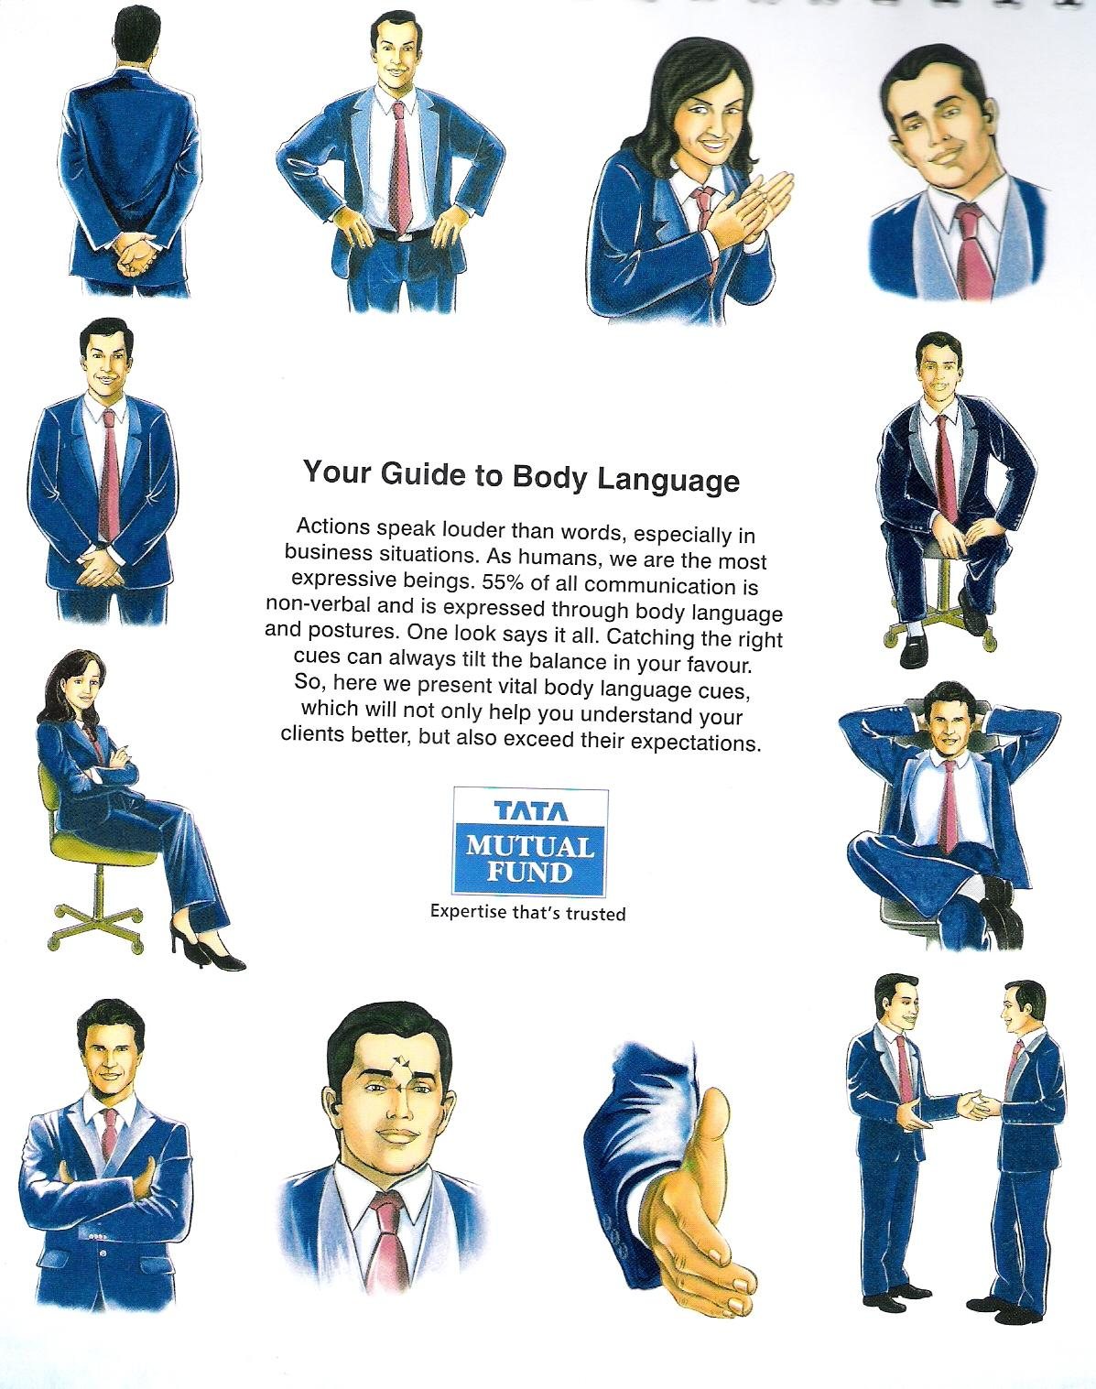

**Task 18. Business lunch or dinner is important part of your successful socialization and future relations with your business contacts. Which of the places below would you take the following guests to for dinner?**

* A group of American engineers
* An important Mexican customer
* Colleagues from your French subsidiary
* An international group of young trainees doing work experience in your company
* A group of high-ranking government officials from Belgium

**Restaurant Balzac**

In the heart of old town, the lovely French [Restaurant](http://www.balzac.lt/) [Balzac](http://www.balzac.lt/) greets its guests with the warm and intimate ambiance of a traditional French farmhouse. Named after the famous [French writer](https://theculturetrip.com/europe/france/paris/articles/in-the-footsteps-of-the-fl-neur-a-literary-tour-of-paris/)and founder of Realism in European literature, Honoré de Balzac, the restaurant serves a variety of classic French dishes including traditional onion soup or oven-baked Burgundy snails for starters, and rabbit in a mustard sauce or duck confit with cowberry sauce for the main course, all accompanied with great selection of French wines.

**Bistro 18**

A simple and charming family-owned restaurant, managed by an [Irish](https://theculturetrip.com/europe/ireland/)-Lithuanian couple, [Bistro 18](http://www.bistro18.lt/) is recognised as one of the best dining options in Vilnius. A winner of TripAdvisor’s [Certificate of Excellence](http://www.tripadvisor.co.uk/PressCenter-i6013-c1-Press_Releases.html) in 2013, the bistro offers a good selection of modern international cuisine, from the warm goat cheese salad and chanterelles with cream and bacon, to scallops with green pea puree and Indian-style red curry with vegetables and basmati rice. The simple and spacious interior, with wooden flooring, white walls and exposed brick vaults, flanked by shelves of wine bottles, ensures a cozy and laid back atmosphere.

**Restaurant Neringa**

The legendary staple of Lithuanian culinary scene, the restaurant[Neringa](http://www.neringahotel.com/en/restaurant-51.html) is considered to be the oldest restaurant in Vilnius. Opened in 1959, Neringa was the most luxurious restaurant in the city at the time, with its interior décor designed by famous Lithuanian artists, architects, sculptors. Since being listed as a ‘state-protected monument of Lithuanian architecture’, the interior with its mosaic floors, frescoed walls and a fountain has remained unchanged, providing guests with a quick insight in the life of artistic elite 40 years ago. The menu features variety of contemporary [European](https://theculturetrip.com/europe/) and Lithuanian dishes along with several of the restaurant’s house classics, on offer over 40 years, such as chicken Kiev or Neringa salad.

**Senoji Trobele**

A small and cozy restaurant, [Senoji Trobele](http://www.senojitrobele.lt/), meaning old hut in Lithuanian, is the best choice to explore traditional Lithuanian cuisine in Vilnius. The venue is well-known for its folk-themed and rustic interior and simple, unpretentious yet delicious traditional Lithuanian dishes, including *zeppelins* – traditional potato dumplings filled with meat, mushrooms or cheese – and variety of hefty meat and fish main courses such as marinated herring or potato pancakes with chicken. The experience of a traditional Lithuanian meal can not be complete without a glass of local beer or sweet mead, a local alcoholic beverage produced from the local honey and herbs.

**Restaurant Rene**

Dedicated to the [Belgian](https://theculturetrip.com/europe/belgium/) surrealist painter [Rene Magritte](http://www.renemagritte.org/), the restaurant [Rene](http://www.restoranasrene.lt/) is a real find. The funky interior is decorated with black and white chessboard flooring, colorful posters of Magritte paintings, and white tablecloths on which guests are invited to draw with pencils provided by the restaurant. The Belgian theme extends to the food, with high-quality traditional Belgian cuisine and the wide choice of Belgian wine and beer. Over the weekend booking in advance is recommended as the restaurant gets particularly busy.

**Task 19. Sort the words into the correct categories in the table below:** *bake, sweet, rich, rice, beef, smashed potatoes, roast, pork, pepper, grill, starter / apetizer, onion, garlic, cabbage, lettuce, salad, main course, chiken, chips, savoury, light, dessert, fry, ham, spicy, lamb, seafood, refreshments.*

|  |  |  |  |  |  |
| --- | --- | --- | --- | --- | --- |
| Parts of the meal | Types of meal | Types of vegetables | Side dishes | Ways of cooking | Words for describing food |
| *Dessert* | *Beef* |  |  |  |  |

**Task 20. Study the menu below and role-play the start of a business lunch:**

|  |  |  |
| --- | --- | --- |
| **AT A RESTAURANT** | | |
| **Helping with the Menu** | **Excuse me** | **Deciding what to order** |
| Let me know if you need any help with the menu.  Oh, that. It‘s a kind of fish.  It‘s like an omelette.  Do you know raviolli? Well, it‘s similar to that. It‘s made with eggs, milk, and sugar. | Can we **have / see** the menu, please?  I don‘t eat **pork.**  **I‘ll have** the pasta.  I‘d like **sparkling / still** water. | Do you know what you‘re having?  Have you decided yet?  That‘s what I‘m going to have for my starter.  I think I‘ll have that for the main course.  I‘m going to have the dish of the day / special |

